2.2 Design and performance Evaluation of a Chebyshev Type I IIR High Pass Filter using MATLAB

CODING:
clc;
clear;
close all;

% Specifications
Rp = 1; % Passband Ripple (dB)
Rs = 40; % Stopband Attenuation (dB)
Wp = 0.5; % Passband Edge
Ws = 0.35; % Stopband Edge

% Find Filter Order
[n,Wn] = cheb1ord(Wp,Ws,Rp,Rs);

% Design High-Pass Filter
[b,a] = cheby1(n,Rp,Wn,'high');

% Frequency Response
figure;
freqz(b,a);
title('Frequency Response');

% Impulse Response
figure;
impz(b,a);
title('Impulse Response');

% Group Delay
figure;
grpdelay(b,a);
title('Group Delay');

% Pole-Zero Plot
figure;
zplane(b,a);
title('Pole-Zero Plot');

fprintf('Filter Order = %d\n',n);
fprintf('Cutoff Frequency = %.4f\n',Wn);

OUTPUT: 1
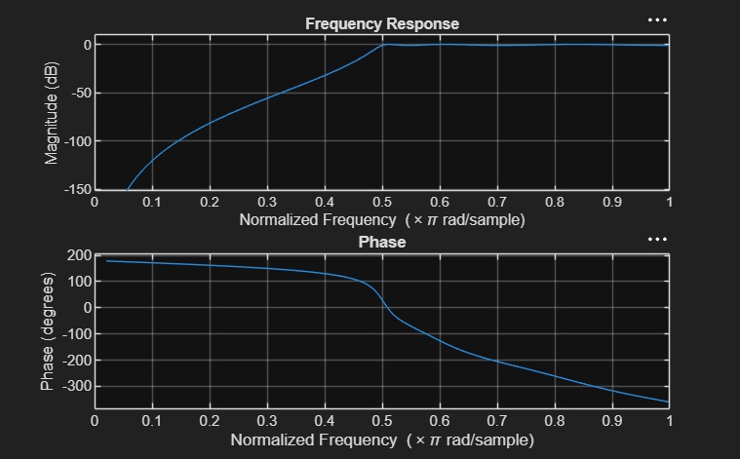

OUTPUT: 2
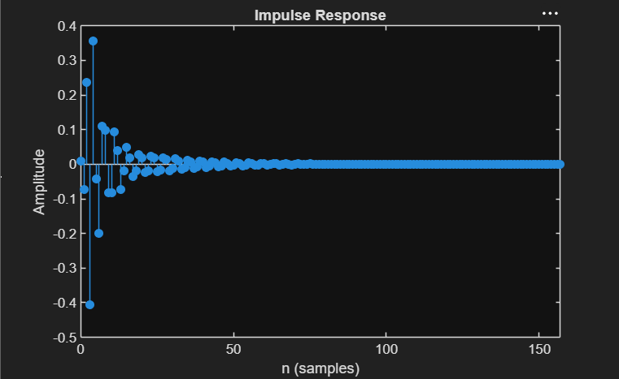

OUTPUT: 3
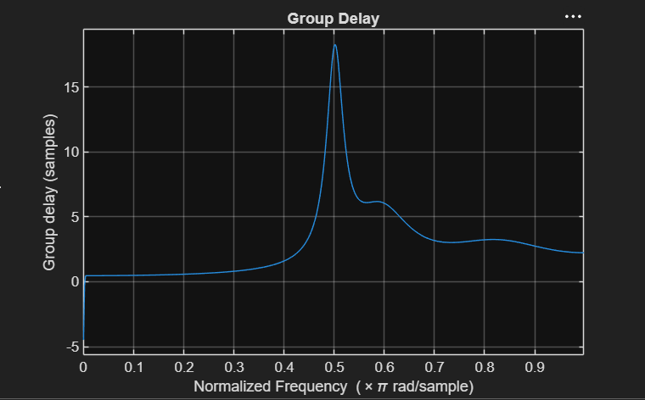

OUTPUT: 4
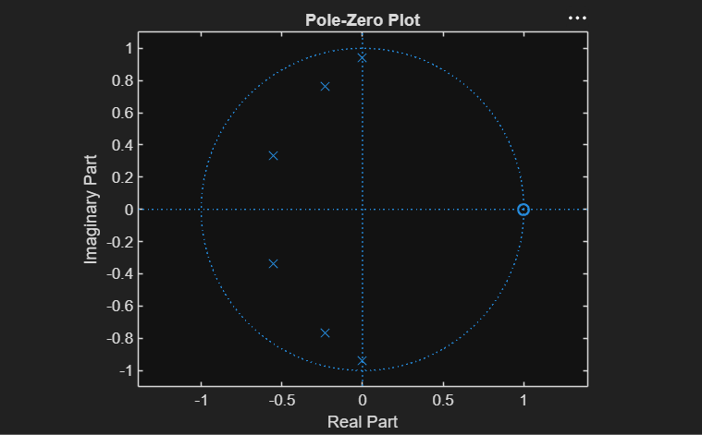

RESULT:
Filter Order = 6
Cutoff Frequency = 0.5000

